X6 Access Control

System User Manual

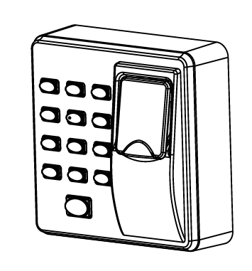

1.Equipment Installation
Wall mount installation
(1)Remove the screw on the (2)Take away the back cover.
bottom of device.
(3)Fix the back cover on the
wall
according
to the
mounting paper.
(4)Fix the device to the back (5)Fix the screw.
cover.
2.Structure and Function
Access Control System Function:
(1)If a registered user verified, the device will
export the signal to unlock the door.
(2)Door sensor will detect the on-off state. If the
door is unexpected opened or improperly closed,
the alarm signal (digital value) will be triggered.
(3)If the device being illegally removed, the device
will export alarm signal.
(4)External exit button is supported; it is convenient
to open the door inside.
(5)External bell is supported.
1
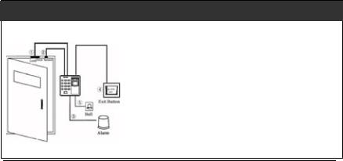

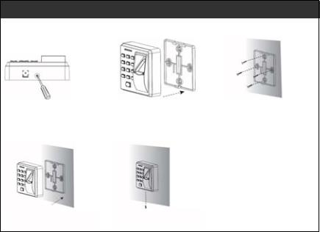

3.Lock Connection
Warning: No operation when power on!
(1) The system supports NO LOCK and NC LOCK. For example the NO LOCK
(normally open at power on) is connected with’NO’ terminal, and the NC LOCK is
connected with ‘NC’ terminal.
(2) When the Electrical Lock is connected to the Access Control System, you need
to
parallel one FR107 diode (equipped in the package) to prevent the
self-inductance EMF affect the system, do not reverse the polarities.
(I)Share power with the lock:
Deviceshare power with the
lock:
ULOCK=12V,
I-ILOCK>1A……
1
Andthe lockis near to the
device.
(II)Does not share power with the lock:
Devicedoes notsharepower
with thelock:
A.ULOCK =12V
≤1A;
I-ILOCK
B.ULOCK ≠12V;
C.The lock is far apart fromthe
device.
I①: ‘I’: device output current, ‘ULOCK’: lock voltage,’ ILOCK’: lock current.
2
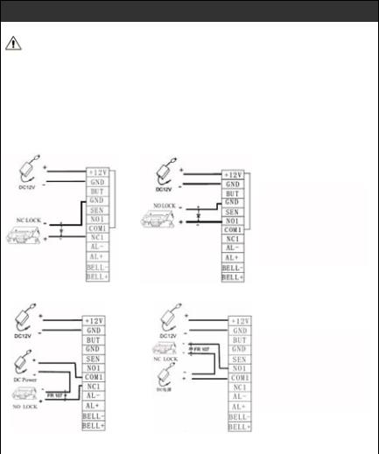

3
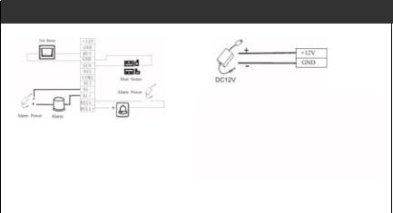
4. Conect with alarm

Notice: Voltage output ≤ DC 12V for Alarm
5.Connect with Power
Input DC 12V, 500mA (50mA standby) Positive is connected with‘+12V, negative is connected with’GND’(do not reverse the polarities

4
Instructions
Buttons represent: [#] means yes, [* ]means Escape
Lights represent: Green means sucess, Red means Failure
Number: Password=4 digits, work code<=5 digits
Tones: Long buzz means success, short buzz twice means failure, short buzz 4 times means wrong action
Notice: make sure you pressed [#] to confirm, [*] exit to initial condition

1. User management
  - Administraction Operations
For the security the data, admin password is needed to operate the machine.
- Register the admin's fingerprint
Press [*]+[#]→Input [1234#]→register fingerprint 3 times (green light on and a long buzz) →press [*] to exit (green light on and a long buzz)
- Modify the admin's fingerprint
Press [*]+[#]→Press admin fingerprint→press [8] (green light on and a long buzz) →register fingerprint 3 times → press [*] to exit (green light on and a long buzz)
- Lost the admin fingerprint
Please contact customer service at: 4006-900-999
  - Add/Edit a User
Each user can regist 10 fingeprint and 1 card at most
Press [*]+[#]→ress admin fingerprint→press [#]→ Input a new/ exist work code [#]→ register fingerprint 3 times (green light on and a long buzz) →press [#] contiue to add new users OR press [*] to escape(green light on and a long buzz)
Notice:
- New user has to put work code,the machine will defultly edit the present user if the number existed.
- After the first fingeprint registered, same user's other fingerprints can be added, 10 pcs at most
- If there is wrong action or repeat occured suring register fingeprint/ cards, machine's red light will be on along with short buzz 4 times, then green light will be on. Continue to register without exit, no operation limits.

  - Register Eight Passwords for Opening the Door
The machine support at most 8groups of door password, each password respond to a group (range: 1~8):
Press [*]+[#]→Press admin fingerprint→press [3] →Input modified group number (1~8) → Put 4 digits password [#] (repeat twice) →press [*] to exit
Notice:
- When a group of password was changed into 00000, then this group of password was shut down
- When a group of password was changed successfully, you can input next group of number to modify directly.

  - User Authentication
Fingerprint / Card / Password authentication
Connect the power, the machine is on the mode of authentication.
Press password [#] / Press fingerprint / Swipe card → Authenticat successfully
Notice:
When use a password , the door can be opened as long as the password is same as one of the 8 groups of passwords. Original 8 groups of password are empty.

  - Delete Users
- Delete a single user
Press [*]+[#]→Press admin fingerprint→press [3] →Press [2] → Put work number [#] / fingerprint / card →press [*] to exit
- Delete all of the users
Press [*]+[#]→Press admin fingerprint→press [9]+[#]→press [*] to exit

2. Acess control management (Default setting is recommened)
  - Configure Unlocking Duration (Default 6 seconds)
Press [*]+[#]→Press admin fingerprint→press [4] →Input unlock duration (1s~10s) →press [*] to exit
When the unlock duration is bigger than 10, red light will be on.
  - Configure Authentication Mode (FP/PW/RF)
Press [*]+[#]→Press admin fingerprint→press [5] →Input authentication mode value [#]→press [*] to exit
Authentication Mode Value Description:

Mode | Value | Description
PW | 1 | Only Password
RF | 2 | Only Card
FP | 3 | Only fingerprint
FP/PW/RF | 4 | Fingerprint or password or card
RF& PW | 5 | Card then password
FP & PW | 6 | Fingeprint them password

  - Configure Alarm
- Alarm Switch (Default ON)
The switch is the master switch of the machine, only when it's on, can the alarm incorrectly, tamper alarm and magnet alarm be working properly. The alarm will be shut dowm when it's off.
Press [*]+[#]→Press admin fingerprint→press [0]+ [1]→Configure main switch [#] (0: ON, 1:OFF)→press [*] to exit
- Tamper Alarm Configure (Default ON)
Only when this function is on, the machine can be alarmed during tampering.
Press [*]+[#]→Press admin fingerprint→press [7]→Configure tamper alarm switch [#] (0: ON, 1:OFF)→press [*] to exit

