2014 Smart Card cloner User's Manual V3.0

2015/11/17
1、Equipment introduction
Power supply :four dry batteries (7 alkaline batteries) or 5V USB power supply.
Tip : voice +LCD.
Operation : physical keyboard
Power : 120mA, power consumption, idle power consumption 50mA, sleep standby power 45uA. Read / write card operation power consumption of each card mode of different 100~150mA, playback voice when the peak current reached >150mA.
Run : the device is idle (no key or USB operation) for more than 20 seconds automatically enter the idle state.

2、Operation
Start: press the button, the device starts.
Shutdown: press the button, the device enters the sleep standby mode.
Select the card mode: (read, write, and enter the card number, you must first select the right card mode).
Method 1: press the MODE key to select the card mode.
Method 2: long press the number keys, fast select the card mode.
Read card: the card is placed in the sensing area (LCD back), then press READ or SCAN.
Write card: the blank card (UID card) in the sensing area, and then press WRITE key.
Number input: press INPUT key, press the number key to enter the card number (decimal), then press INPUT key to confirm the input.
IC card decoding: the IC card into the sensing area. using USB cable connected to the computer. running computer on the smart card decoding software. click on the start button. After the successful decoding. the IC blank card into the sensing area. press WRITE key to write a card.
Note: please see the following steps in detail.

3、Detailed IC card decoding operation
Using a USB cable connected to your computer. press thebutton to boot the device. the display "disclaimer" page (Figure 1). open My Computer (Computer) displays a removable disk. open the removable disk. the "Smart card decoding software" and "2014 Smart Kake Long User's Manual" copy to the local computer (Figure 2).
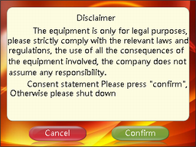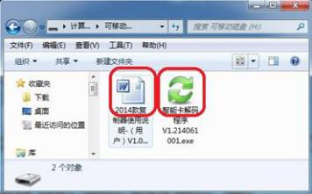
(Figure 1) (Figure 2)
Press the OK button on the device. the device enters user interface (Figure 3). the IC card on the induction area. "Smart card decoding software" running on your computer. then click the button to start decoding (Figure 4). (Each square represents a sector of the IC card password)
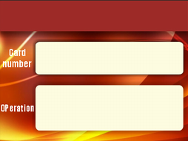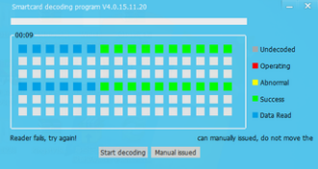
(Figure 3) (Figure 4)
After successfully decoded. the IC blank card (UID card) into the sensing area, press the WRITE Key to write the card. (If "successful number" prompt, indicating that some sectors write fails, adjust the position of a blank card, then press WRITE key, try to write the card again)

Note:
- IC card decoding time-consuming individual sectors are not the same (are normal within 40 minutes), in case of decoding time-consuming long, there are still some sectors did not successfully decoded. the decoding can be stopped manually issued has been successfully decoded data, then write cards; (presence may be able to normal use)
- Tip "decoding failed, please try to decode an upgraded version of" when. That means that the card can only be used with the detector decoding.

